Ocean Powered Hydrogen Oxygen Plant (OPHOP)
P. S. Mithun^{1*}, J. Muhammed Sujah², A. P. Pranav Prathap³, N. Ashik Muhammad⁴,
N. Nadir Mohamed⁵, Shimi Mohan⁶
^{1,2,3,4}Student, Department of Electrical and Electronics Engineering, Musaliar College of Engineering, Trivandrum, India
⁵Assistant Professor, Department of Electrical and Electronics Engineering, TKM College of Engineering, Kollam, India
⁶Associate Professor, Department of Electrical and Electronics Engineering, Musaliar College of Engineering, Trivandrum, India
*Corresponding author: mithunps@ieee.org
Abstract: This paper aims at describing a small scale prototype of ocean energy converter system for hydrogen production, promoting the opportunity of such installation in coastal areas. The process of producing hydrogen from sea-water identifies ocean energy as the most promising solution for electricity generation as well as hydrogen production. Hydrogen is considered as the most promising secondary sources, criticism arises from different sectors of the world since hydrogen production requires energy consumption. Present scenario of utilizing energy from fossil fuel for the production of hydrogen has to be avoided as part of sustainable development. Fuel demanding sectors such as transportation, demand for the increased hydrogen production, which is considered as energy carrier for future applications. Sustainable Engineering suggests utilization of environmentally friendly technologies argued that use of hydrogen to empower internal combustion engine vehicles as well as fuel cell vehicles, can satisfy the energy Thus the dependency on fossil fuel in automobile industry as well as for hydrogen which will contribute in increased hydrogen production. So this paper focuses on the production of hydrogen more economically as well as eco-friendly.

Keywords: Energy carrier, Hydrogen, Internal combustion, Sustainable engineering.

Introduction
Being a developing country, India requires a lot of power as part of development in all the sectors. But for meeting the power requirement, we mostly depend on the fossil fuels especially in the automobile industries. About 56% of total power generated in India is from thermal power plants which use coal as the fuel, due to which pollution increases abruptly. By the increase of industrial sector as well as transport sector, the amount of carbon emission is also increasing leading to environmental pollution which is a major issue to be considered seriously. Since fossil fuels are depleting and are not eco-friendly, sustainable development always suggests for a transformation of dependency from fossil fuels to renewable energy sources.

Due to the shortage of fossil fuels and limitations of using natural fuels, the government has already started to shift it focus on various renewable energy resources like wind, solar, tidal and the underlying technologies used to extract energy from these resources. So by the use of renewable resources these problems can be solved to an extent. In addition, the availability and price concerns of conventional fuels have increased the need for developing sustainable energy sources based on renewable energy and low or zero emission energy conversion technologies. So we must switch to a greener fuel that can be hydrogen, the future fuel. Hydrogen has been recognized as the most promising futures carrier of energy. The sectors which require hydrogen are industrial sector, transportation sector, aviation sector etc. The existing technology of production of hydrogen is from fossil fuels that are by reforming of carbonaceous sources, ammonia cracking, coal gasification are some of the conventional techniques that are used for the production of hydrogen gas. But the disadvantage of these techniques is that they produce pollution. So we can create hydrogen by electrolysis of water, which is pollution free. We can use renewable resources for production of hydrogen at low cost. Ocean is one of the places where lots of resources are present, that can be used for the production of hydrogen gas and the water from the ocean can be used.

Existing System for Hydrogen Production
The hydrogen can be produced by many methods. But all these methods cause pollution. Since one of our prime aims is to reduce pollution, these methods have to be avoided. The existing methods are briefly explained below:

Reforming of Carbonaceous Sources
Conventional technologies for production of hydrogen are: i) Steam Methane Reforming ii) Partial Oxidation, iii) Auto-Thermal Reforming, iv) Methanol Reforming, v) Ammonia Cracking, vi) Thermo-catalytic Cracking of Methane, and vii) Novel Reformer Technologies. Steam Methane Reformers are commercially available for hydrogen production [3].

Membrane Reactors for Steam Reforming
It is another promising technology depending upon on the temperature, pressure and the reactor length, methane is completely converted, and very pure hydrogen is produced. This allows its operation at lower temperature and lower cost. A potential advantage of this system is the simplification of the process design and reducing the capital cost. Japan has built and tested a small membrane reactor for production of pure hydrogen from natural gas (at a rate of 15 Nm³/h) [3].

Partial Oxidation (POX) Reformer
This technology is used to implement a natural gas reformer filling station to supply hydrogen to fuel cell buses and Hythane buses at Thousand Palms, California. Several companies are involved in developing multi-fuel fuel processors for 50 kW fuel cell vehicle power plants and to develop gasoline fuel processors based on POX technology [3]

Auto-thermal reformers
The auto-thermal reformer is not requiring external heat source and no indirect heat exchangers. Heat generated by the partial oxidation is utilized to drive steam reforming reaction. This is more compact than conventional steam reformers, and will have a lower capital cost and higher system efficiency than partial oxidation systems.

Methanol Reformation
It takes place with steam at moderate temperatures (250-350oC). These reformers have been demonstrated by several automakers in PEM fuel cell vehicles, where methanol is stored on board. There is no fuel cell vehicle manufacturer is currently using this technology. The advantages are compactness, better heat transfer, faster start-up and potentially lower cost. Internationally, units are produced for steam reforming of alcohols, hydrocarbons, ethers and military fuels. A multi-fuel processor was demonstrated for pure hydrogen production via steam reforming of methanol, using palladium membrane and micro-reactor technology to create portable hydrogen source for fuel cells [3].

Ammonia Cracking
Ammonia is widely distributed in the country and available at low cost. It is relatively easy to transport and store, compared to hydrogen. It can be cracked at 900oC with up to 85% efficiency. Water is not required as co-feed. A costly separation unit Pressure Swing Adsorption unit for separating H2 and N2 would be required. Thermo-catalytic cracking of methane is still away from commercial application for hydrogen production. The primary issues are low efficiency of conversion and coking but relatively low capital costs are projected [3].

Sorbent-enhanced Catalytic Steam-reforming System
Production of syngas using novel reformer technologies has a substantially higher fraction of hydrogen than that produced in a catalytic steam-reforming reactor. Sorbent-enhanced systems are still at demonstration stage, and shows promise for very low cost. Issues to be resolved include catalyst and sorbent lifetime and system design [3].

Hydrogen Separation through Ceramic Membrane
Globally, some research groups are developing ceramic membrane technology for separation of hydrogen from syngas. Conceptual designs were carried for a hydrogen-refueling station dispensing 15000 m3/day hydrogen at 350 bar. This route offers 27% saving cost compared to trucked-in liquid hydrogen.

Photo-catalytic and photo-electrochemical routes for hydrogen production
These are also explored globally by many research groups. Till date no large scale units has been successfully designed and demonstrated. Concerted intensive efforts, however, are required to generate basic information and know how to take this area to the production for decentralized applications [3].

Need for the Proposed System
The production of hydrogen by conventional techniques is not pollution free. An electrolyser is a device which splits water into hydrogen and oxygen using electricity. The renewable power can be extracted from ocean, which can be used for the production of hydrogen gas. The renewable energies like wind energy, tidal energy, solar energy, wave energy, ocean thermal energy conversion(OTEC) etc. can be used for creation of electrical energy. This energy will in different forms (alternating current(AC) or direct current(DC)), if more than one renewable sources are present, then they can be integrated and their output is converted to DC, which is then fed to the electrolyser which splits water into hydrogen and oxygen. Thus the obtained hydrogen is pollution free as well as cheap.

Major Components Required

Source of Renewable Energy
The renewable sources from ocean can be:

Photovoltaic Energy
Solar resources are available in many country and solar photovoltaic (PV) and concentrating solar power (CSP) technologies are often want to convert this solar resource into electricity, Solar PV deployment reached 291 GW at the top of 2016, while deployment of CSP remain in its infancy at 5 GW. The cost of producing solar panels has plummeted dramatically within the last few decade, making them not only affordable but often the most cost effective sort of electricity. Solar panels have a lifespan of roughly 30 years, and come in variety of shades counting the sort of material utilized in manufacturing.

Wind Energy
The rotor turns the drive shaft, which turns an electrical generator. Wind power is one among the fastest-growing renewable energy technologies. Usage is on the increase worldwide, partially because costs are falling.

Wave Energy
There is a good range of wave energy technologies. Each technology uses different solutions to soak up energy from waves, and may be applied counting on the water depth and on the situation (shoreline, near shore, off shore). Although there’s a good home in technologies that signals that the world has not yet reached convergence, it also shows the many different alternatives to harness wave power under different conditions and emplacements. Making the jump to the complete commercial phase requires some research on the essential components to scale back and increase the performance. Some of the examples of extracting wave energy are shown in fig. 1. The disadvantage is that it’s very difficult to extract this power, there are chances of corrosion of metals due sea water.

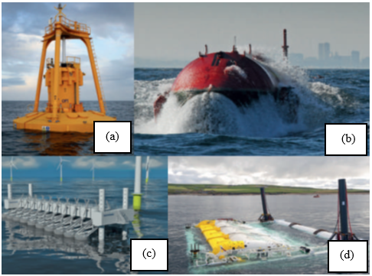
Fig. 1. (a) Ocean Power Technologies Inc.; (b) Pelamis Wave Power; (c) Wave Star AS; (d) Aquamarine Power

Tidal Energy
The rise and fall of the tides – in some cases quite 12 m – creates P.E. The flows due to flood and ebb currents create kinetic energy. Both sorts of energy are often harvested by tidal energy technologies as renewable energy. Tidal energy technologies aren’t new: examples were already reported in Roman times and ruins of installations – tidal mills – are found in Europe from round the year 700.

Ocean Thermal Energy Conversion
The advantages of OTEC include having the ability to supply electricity on endless (non-intermittent) basis, while also providing cooling without electricity consumption. Recent studies suggest that total worldwide power generation capacity might be supplied by OTEC, which this is able to haven't any impact on the ocean’s temperature profiles.

Converter
The technological challenge is that the tiny temperature difference requires very large volumes of water at minimum pressure losses. The converters used are for integrating different sources of energy together, to convert the generated power to direct current. Different sources produce different types of current (AC or DC). For the purpose of electrolysis we require direct current so each source is provided with their suitable converter, at the end they are integrated and the output DC is fed to the electrolyser.

DC link
The output of the converter is given to the DC link into which the AC grid can also be connected. When the power from the ocean is insufficient, the power can be extracted from the grid. This DC link is connected to the electrolyser.

Electrolyser
The alkaline electrolyser currently dominates global production of electrolytic hydrogen [2]. The gases produced by the electrolyser are hydrogen and oxygen is forwarded to storage section.

Storage
The generated gases are stored into suitable chambers or to cylinders. The oxygen and hydrogen produced is stored in different chambers. The chambers are kept highly concealed, as it’s highly explosive.

Transportation
The stored gases are transported to the respective users through different transportation mediums. That may be through tankers, container ships, trains or pipe lines. The pipe line is the most efficient method of transportation of gas to distant location. Figure 2 shows Gail gas pipeline to different parts of the country, in such way the hydrogen can also be transported or can be injected to that pipeline also(exceptional case). The oxygen can be exported to their users in the same manner.
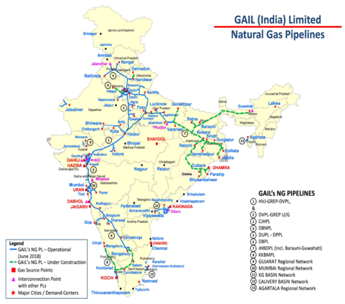
Fig. 2. Natural gas Pipeline laid across the country

Block Diagram
The block diagram of the system is shown in the figure 3. The figure shows that each renewable energy source from the ocean is fed to their respective converters; the converter converts the input supply to the suitable form and is given to the DC link of capacitor bank.
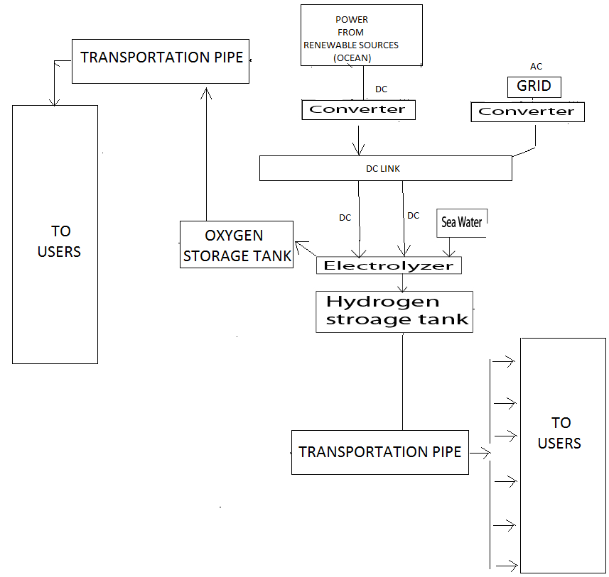
Fig. 3. Block diagram of the proposed system

The power from DC link is then fed to the electrolyser. The sea water from the ocean is pumped to the electrolyser chamber, and then the electrolysis is conducted. The generated gases such as hydrogen and oxygen are separated and stored in storage system from which the gases can be transported through their respective transportation channels. When the system is not engaged in the production of gases, the energy from DC link can be given to the AC grid. Thus, the non-conventional energy sources can be completely utilized.

Comparison study of Proposed System
Because hydrogen features a low volumetric energy density, it’s stored onboard a vehicle as a gas to realize the golf range of conventional vehicles. Hydrogen has more energy per unit mass than other fuels (61,100 BTUs (British thermal unit) per pound versus 20,900 BTUs per pound of gasoline). Compressed gaseous hydrogen is less dense than liquid hydrogen. According to volume to power calculations 1Kg of hydrogen is equivalent to 15.16 Kg diesel. Comparison between battery operated vehicle and fuel cell operated vehicle is done in table 1.
Table 1
Fuel cell powered vehicle vs. Battery operate vehicle
Fuel cell powered (Hydrogen) | Battery powered
1) Light weight | 2) Heavy
2) Occupies less area | 2) Occupies more area
3) Less amount of time required for refueling | 3)More time required for recharging
4) Less safety | 4) More safe
5) Covers more distance | 5) Covers less distance
6) Produces pure water and heat as by product. | 6) Produce heat as byproduct.

Conclusion
The paper mainly emphasize on the production of hydrogen in economical and eco-friendly manner. From the comparative study done, it is clear that the hydrogen has a great potential to power the future economically in a sustainable way as it has zero carbon emission. By the use of renewable resources we can produce clean and free hydrogen. Another advantage of this system is the availability of free oxygen, which can be used commercially for medical sector as well as industrial sector. In this manner, the renewable resources can be utilized more efficiently.

References
- S. M. B. Billah, K. M. Kabir, M. O. Islam, S. Barua, M. S. Mahmud and M. S. Hossain, "Hydrogen energy storage based green power plant in seashore of Bangladesh: Design and optimal cost analysis," 2017 International Conference on Innovations in Green Energy and Healthcare Technologies (IGEHT), Coimbatore, 2017, pp. 1-5.
- L. A. Hamane, M. Hamane, M. Belhamel and B. Benyoucef, "Prospect for hydrogen production from wind in Algeria," 2011 10th International Conference on Environment and Electrical Engineering, Rome, 2011, pp. 1-5.
- Sub-Committee on Research, Development & Demonstration for Hydrogen Energy and Fuel Cells Steering Committee on Hydrogen Energy and Fuel Cells, Ministry of New and Renewable Energy, Government of India, New Delhi March, 2016 Report on Hydrogen Production in India.
- H. Tebibel, "Wind Turbine Power System for Hydrogen Production and Storage: Techno-economic Analysis," 2018 International Conference on Wind Energy and Applications in Algeria (ICWEAA), Algiers, 2018, pp. 1-6.
- O. Bilgin, "Evaluation of hydrogen energy production of mining waste waters and pools," 2015 International Conference on Renewable Energy Research and Applications (ICRERA), Palermo, 2015, pp. 557-561.

